MCTA 3203
MECHATRONICS SYSTEM INTEGRATION
TITLE

PROTOTYPE MINI WASHING MACHINE

AUTHORS

G14
Ahmad Aidil Adha bin Rosehaizad [2118165],Ahmad Hafizi Bin Ishak [2111775], FIRZANAH BINTI ABDUL AZEEZ[2211430]
SECTION 2

DEPARTMENT OF MECHATRONICS ENGINEERING,
INTERNATIONAL ISLAMIC UNIVERSITY MALAYSIA

Email:
https://github.com/firzanahazeez-gif/mini-project

ABSTRACT

This project focuses on the design and development of a Mini Washer Machine prototype with Bluetooth monitoring using the HC-05 module. The main aim of this project is to demonstrate basic automation concepts used in household appliances by integrating embedded systems, motor control, and wireless communication. An Arduino Uno is used as the main controller to control the washing and spinning operations of the machine. A DC motor, driven by an L298N motor driver, is used to simulate the rotation of the washing drum.
The washing cycle is started using a push button, and the system sends real-time status updates to a smartphone through Bluetooth using a serial terminal application. The prototype is able to perform automatic wash and spin cycles with forward and reverse motor rotation. Overall, the system operates reliably and successfully demonstrates the integration of hardware and software components, making it suitable for learning and demonstration purposes in a Mechatronics System Integration (MSI) project.
1.INTRODUCTION
washing machines are among the most widely used domestic appliances . These appliances assist by reducing manual labor, thereby increasing productivity, by performing washing and rotating cycles automatically. The most recent washing machines consist of electrical, mechanical, and electronic elements, such as motors and control units, which work together. Due to their complexity, washing machines are examples of applications of concepts related to mechatronics and automation.
In engineering learning, simplified models are developed to teach students the concept of complex systems. Regular washing machines are too big, too costly, and not safe to use as learning tools. Thus, a mini version is more suitable for learning the basic concept of working. By constructing a mini-model of a washing machine, students can understand the link of various hardware parts to the controlling system of embedded systems.
This project is based on the development of a Mini Washer Machine Prototype, utilizing the Arduino microcontroller. The project incorporates a DC motor to implement the washing and spinning cycles of a real washing machine. An L298N motor driver is incorporated to manage the rotation and speed of the motor. The washing cycle is automated through a simple timing control system, where the motor rotates in one way for washing and in the opposite way for spinning.

To enhance user interface, Bluetooth communication is introduced with the use of the HC-05 Bluetooth Module. Therefore, the system is able to transmit status information such as the mode of either washing or spinning to a mobile phone using a Bluetooth Serial Terminal. A push button is used to trigger the laundry machine, while an LED is used to indicate whether the system is working or not.
The main objective of this project is to ensure that students acquire hands-on experience in Mechatronics System Integration. In this project, the students pick up information on the programming of microcontrollers, motor control, interfacing hardware, and basic wireless communication. The mini washer machine developed hence provides an easy and efficient platform to understand how automated household appliances work while keeping it safe, low-cost, and also for educational use.

2.METHODOLOGY
2.1 PROJECT OVERVIEW
A prototype of the Mini Washer Machine was developed to realize a basic working principle of an automatic washing machine based on embedded control and wireless communication. The project combined hardware with software for the development of a simple and functional system, applicable in any learning environment.
The selection of required components marked the beginning of the development process, which included an Arduino Uno, a DC motor, an L298N motor driver, an HC-05 Bluetooth module, a push button, an LED, and a power supply. An Arduino Uno was utilized as the main controller for handling motor operations, user input, and Bluetooth communication.
A flowchart was made to represent the working principles of the system. Firstly, when powered on, the Arduino waits for a button press. Once the button is pressed, the system starts the wash cycle. During the washing phase, the motor turns forward and sends "WASHING" as its status to the smartphone via Bluetooth. Once the washing time is over, the system switches to the spinning phase, where it rotates the motor in a reverse direction and sends an "SPINNING" status update.
After the spinning process is over, the motor stops, and a completion message is received by the smartphone. The system then goes back to its idle state, awaiting the next operation. This model for development helps the system to run smoothly and clearly illustrate how the principles of the system work.
MATERIALS AND EQUIPMENTS
1. Arduino Microcontroller
2. Jumper Wires
3. DC Motor
4. Motor driver
5. Bluetooth module
6. Push Buttons
7. LED

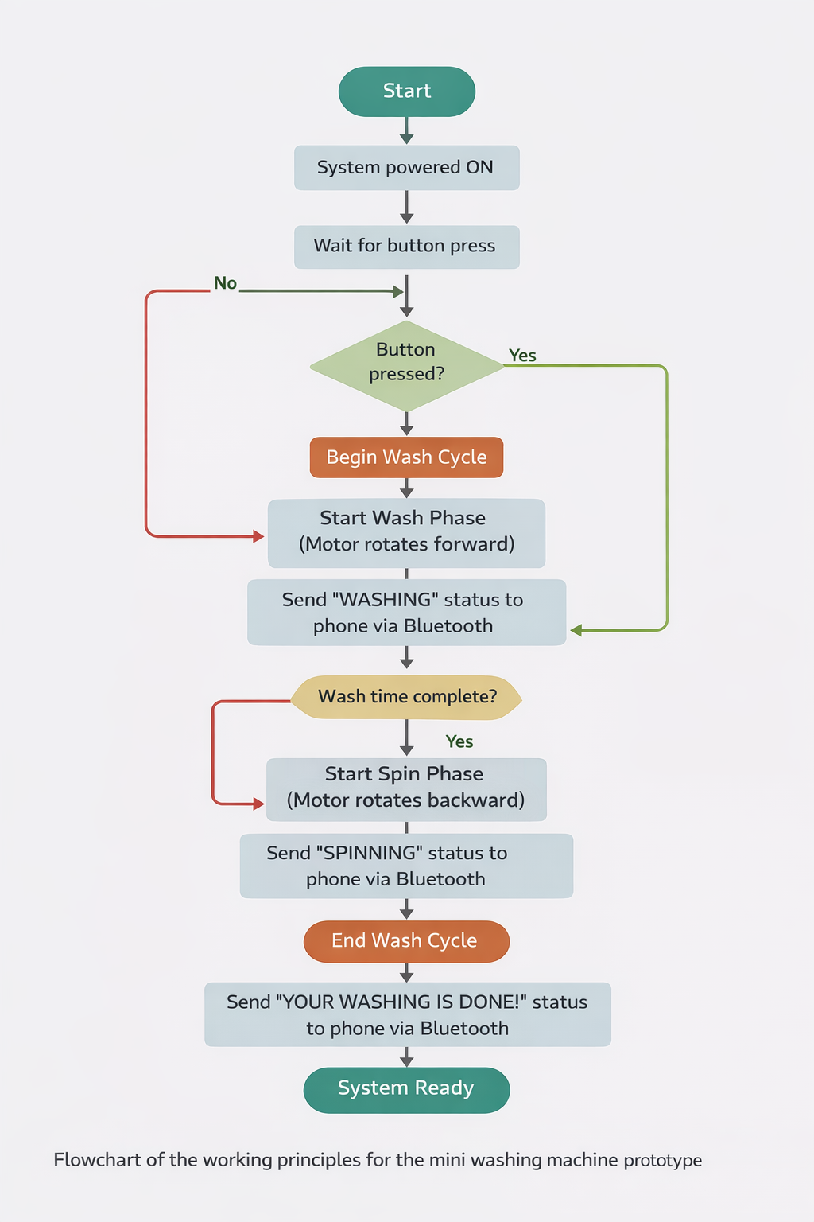

2.2 Operating Principle
When the push button is pressed, the Arduino initiates a predefined to a wash cycle. The cycle consists of two main stages: washing and spinning. During the washing stage, the motor rotates in one direction for a fixed duration. In the spinning stage, the motor reverses direction for a shorter duration. Throughout the cycle, status updates are sent to a smartphone via Bluetooth.
2.3 EXPERIMENT SETUP
HARDWARE DESIGN
1. Arduino Uno Microcontroller
Arduino Uno serves as the primary controller of the mini wash machine system. It takes care of reading inputs from the push button, regulating the direction and speed of rotation of the motor, manipulation of the LED indicator, and overall Bluetooth interfacing with the mobile device. Arduino Uno was chosen owing to its ease of handling, adaptability, and compatibility with a diverse array of modules. Such characteristics make Arduino Uno an excellent tool for small-scale prototyping.
2.Motor Driver & DC Motor
The project makes use of an L298N dual H-Bridge motor driver to drive the DC motor. Using the motor driver, the DC motor can now move in both clockwise and counter-clockwise motions depending on the polarity of the voltage applied to it. The DC motor can now stop and change direction in an instant. The motor can vary speeds using Pulse Width Modulation on the enable pin of the motor driver.
3. Bluetooth Module (HC-05)
An HC-05 Bluetooth module will be used to create a wireless serial communication link between the Arduino Uno and a smartphone. This module can transmit data at a default baud rate of 9600 bps and enable real-time data transmission of system status changes. SoftwareSerial communication will be used to connect to this module, ensuring that the hard-wired serial port can be used for other applications like debugging.
4. User Interface Components
Push Button: This is used to give the user the option of manually starting the wash cycle. The system also employs the use of an LED indicator to show the operational status of the system. The LED indicator lights up to signal to the user that the system is in operation.
SOFTWARE DESIGN
1. Program Structure
This software is developed in the Arduino IDE. It includes initialization routines, a main loop that continuously runs to keep the system monitoring, and several user-defined functions that manage the motor control and Bluetooth communication.
2. Algorithm of Wash Cycle
Another implementation is the wash cycle using time-based control with the millis() function. This avoids blocking delays and thus can permit periodic Bluetooth updates. The algorithm includes:
Button press detection
Washing phase activation
Transition to spin phase
Completion and system reboot
3. Bluetooth Status Updates
During operation, the system sends status messages to the smartphone every two seconds. It shows the current phase of the operation-washing or spinning-and the remaining time, enhancing transparency and user awareness.

CIRCUIT CONNECTIONS

Power Supply : A 5 V switching power supply is used to power the system. The supply is connected to the L298N motor driver, which also provides regulated 5 V output to the Arduino.

2. Motor Driver Connections
- ENA → Arduino Pin 9 (PWM)
- IN1 → Arduino Pin 7
- IN2 → Arduino Pin 6
- OUT1 & OUT2 → DC motor terminals

3. Bluetooth Connections
- VCC → Arduino 5 V
- GND → Arduino GND
- TXD → Arduino Pin 10
- RXD → Arduino Pin 11

4. Input and Indicator Connections
- Push Button → Arduino Pin 2 and GND
- LED → Arduino Pin 13 via 220 Ω resistor
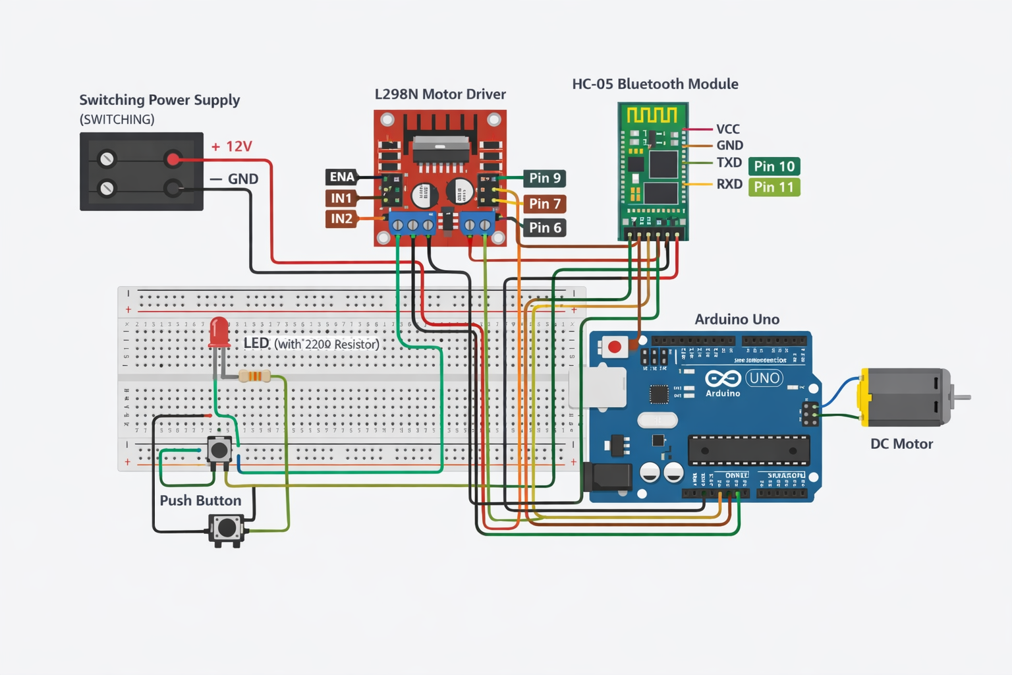
3.RESULT AND DISCUSSION
RESULTS AND DISCUSSION
The Mini Washer Machine prototype was used to test its performance regarding the working of the motors and the functionality of the Bluetooth connection. In this process, the DC motor ran properly for both the washing and spin phases of the machine. The motor also turned in one direction during the washing process and changed direction properly during the spin phase.
The washing cycle performed by the microcontroller followed accordingly using time control programming. The motor turned on, reversed, and turned off accordingly without any interruptions. This demonstrates that the programming logic in the Arduino microcontroller had been written aptly. Bluetooth communication through the HC-05 module connecting the microcontroller functions performed in the correct manner by displaying messages like ‘WASHING,’ ‘SPINNING,’ and ‘YOUR WASHING IS DONE’ in a smartphone Bluetooth terminal app.
Push button functioned as expected after every click, and the LED indicator lit up to indicate the working of the washing machine. Thus, the prototype of the washing machine has successfully demonstrated the basic working of an automated washing machine.Although the system uses fixed timing and speed, it effectively integrates hardware control, embedded programming, and wireless monitoring, making it suitable for educational and demonstration purposes.
3.3 SAFETY CONSIDERATIONS
Safety consideration was also given to the design and implementation of the prototype. All system operations run on a very low voltage level of 5 V, significantly reducing electrical hazards during testing and operation. All electronic components are properly insulated and securely mounted to minimize any possibility of a short circuit or accidental contact.
However, since the prototype does not have any safety interlock mechanisms, users are cautioned to avoid interactions with moving parts when the system is running. The operation requires manual supervision at all times for safety in use. The prototype should be handled with care and operated in a controlled environment for its mechanical or electrical safety.
Overall, it shows some of the basic working principles in an automated washing machine system, but more safety features and sensing elements might be needed before commercial usage.
4. CONCLUSION AND RECOMMENDATION
4.1 CONCLUSION
This project has successfully developed a prototype of a mini smart washing machine using the Arduino Uno microcontroller. This device has a DC motor, motor drive, Bluetooth device, and basic interface elements. A pushbutton is used for starting the machine. The status of the machine is updated through a smartphone using a Bluetooth device.
This project serves as an example of a mechatronic system integration involving components like actuators, controllers, and wireless communication modules. This project also offered a valuable experience in areas like motor control, embedded programming, and system integration, thus meeting the course objectives.
4.2 RECOMMENDATION
However, for future enhancement, an emergency stop button could be implemented for immediate shutting down of the system during unsafe and unexpected situations. Moreover, various other functions like water level detection, loading, and variable washing programs can also be embedded into the system for its further enhancement. Additionally, the monitoring and controlling concept of IoT can also be applied.

REFERENCE
Sérgio, A., Duarte, J., Relvas, C., Moreira, R., Freire, R., Ferreira, J., & Simões, J. (2003). The design of a washing machine prototype. Materials & Design (1980-2015), 24(5), 331–338. https://doi.org/10.1016/s0261-3069(03)00042-6
HC-05 - Bluetooth Module. (n.d.). Components101. https://components101.com/wireless/hc-05-bluetooth-module
Texas Instruments, “L298 Dual Full-Bridge Driver Datasheet,” 2020.
https://www.st.com/resource/en/datasheet/l298.pdf
Hariulnizam, A. J., & Khairulmaini, M. (2023). ALENTA: prototype of a mini washing machine for college students. In Zenodo (CERN European Organization for Nuclear Research). https://doi.org/10.5281/zenodo.8106052
Shi, Y., Qiu, G., & Wang, N. (2020). Basic microcontroller use for measurement and control. In Virginia Tech Publishing eBooks. https://doi.org/10.21061/introbiosystemsengineering/microcontroller
Mowla, M. N., Mowla, N., Shah, A. F. M. S., Rabie, K. M., & Shongwe, T. (2023). Internet of Things and Wireless sensor networks for smart agriculture Applications: a survey. IEEE Access, 11, 145813–145852. https://doi.org/10.1109/access.2023.3346299
Ashraf, I., Umer, M., Majeed, R., Mehmood, A., Aslam, W., Yasir, M. N., & Choi, G. S. (2020). Home automation using general purpose household electric appliances with Raspberry Pi and commercial smartphone. PLoS ONE, 15(9), e0238480. https://doi.org/10.1371/journal.pone.0238480
Sarraf, G. (2025, January 27). What is a Motor Driver? Understanding the Basics and Applications. ThinkRobotics.com. https://thinkrobotics.com/blogs/learn/what-is-a-motor-driver-understanding-the-basics-and-applications

